HIERARCHY OF CONTROLS
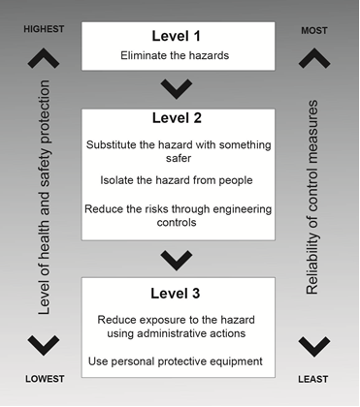
Source: Code of Practice on Risk Management

