NDS Quality Assessment Workbook

For NSW disability services standards

Prepared for National Disability Services NSW

By

Breaking New Ground ABN 21 948 817 923

Bradfield Nyland Group & BNG NGO Services Online February 2013

Contents

Introduction 2

Self-assessment and verification 4

Evidence 7

The NSW Disability Services Standards 8

Other standards 9

Key Performance Indicators 10

How to use the self-assessment workbook 11

Overview 13

Standard 1: Rights 17

Evidence Guide: Rights 20

Standard 2: Participation and Inclusion 22

Evidence Guide: Participation and Inclusion 24

Standard 3: Individual Outcomes 27

Evidence Guide: Individual Outcomes 29

Standard 4: Feedback and Complaints 32

Evidence Guide: Feedback and Complaints 35

Standard 5: Service Access 38

Evidence Guide: Service Access 40

Standard 6: Service Management 43

Evidence Guide: Service Management 47

Workbook: Recording Template 50

Workbook: Introduction

Introduction

Quality management provides a framework for service providers to understand what works well in their organisation, what needs to be improved and what needs to change to meet the needs of people receiving services. It is an important part of making sure that there are consistent and effective ways of managing service delivery and that the services provided are working well for the people receiving those services. Providing assurance of quality services is particularly important in the context of person centred approaches to service delivery and the transition to individualised funding arrangements.

For more detailed information and a guide to implementing a quality management system in your organisation, go to the Quality Management chapter of It’s Your Business¹.

Quality management for disability services providers in NSW is guided by the NSW Quality Framework, developed as part of a nationally consistent approach to quality service provision in the disability sector. The focus of the Framework is on service providers developing a culture of continuous improvement and undertaking regular self-review of performance that takes into account feedback from people with a disability, their families and carers.

Verification against the NSW Disability Services Standards is the core component of the NSW Quality Framework.

The National Disability Services (NDS) Quality Assessment Tool has been developed to assist service providers to conduct their self-review and to prepare for verification against the NSW Disability Services Standards. The NDS Quality Assessment Tool is an online system which enables service providers to work through a detailed self-assessment against the NSW Disability Service Standards in a simple and systematic manner and to monitor their performance against Key Performance Indicators (KPIs). A more comprehensive version of this online tool, incorporating automatically generated work plans and resources, guides and templates to assist service providers in their compliance work, is also available from NDS.

For more information about the NDS online tools, and how they can assist your organisation meet quality requirements, go to the NDS website².

This workbook has been developed for service providers using the NDS Quality Assessment Tool. It provides an overview of the verification pathway and the NSW Disability Services Standards, and a self-assessment guide that service providers can use to self-rate against the Standards. The workbook also provides examples of the types of evidence that a service provider could use to demonstrate compliance with each standard. It can be used to guide a service provider through reviewing the standards and identifying relevant evidence prior to completing online assessments and uploading evidence to the NDS Quality Assessment Tool.

1. http://www.adhc.nsw.gov.au/sp/training_and_development/good_governance

2. http://www.nds.org.au/

Self-assessment and verification

Verification against the NSW Disability Services Standards is a central part of the quality requirements for NSW service providers. The verification process requires that an external, independent agency (‘third party verifier’) conducts a review of the service provider’s performance regarding the standards and provides a report on the extent to which they meet the requirements of the NSW Disability Services Standards³. This report will indicate whether the service provider meets all the standards or needs to undertake some improvement work to do so.

Self-assessment or review is the preparation for verification or accreditation, but it is also the central process of ongoing continuous improvement. Self-assessment against standards involves reviewing each practice requirement for the standards, deciding whether the service meets the requirement and identifying how it can demonstrate this (that is, provide evidence of compliance).

Self-assessment enables a service provider to:

review the extent to which they meet standards

review performance against KPIs

identify and make any improvements that need to be made to meet standards requirements

plan for future improvements in performance against KPIs

The diagram below shows the main steps to verification and its relationship to maintaining quality over time.

Step 1. Implement quality management system

Review options and select quality management system

Step 2. Self-assess against Standards

Check for recognition against any existing accreditation

Conduct self-assessment against Standards

Step 3. Undertake third party verification

Select verifier from NDS list

Participate in external review

Review any recommended action

Implement improvements

Step 4. Verification

Step 5. Maintain continuous improvement

Regular re-assessment

Implement continuous improvement plan

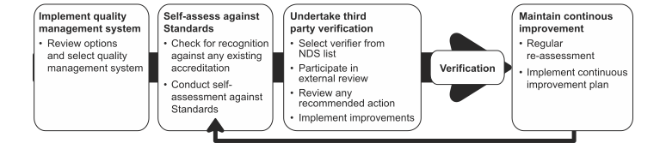

The NDS Quality Assessment Tool provides an online electronic workbook to guide the service provider through the self-assessment process. The Tool also automatically processes the answers given to workbook questions and provides a progress report on the extent to which the service provider is meeting the standards.

Where a service provider already has accreditation under another set of standards that has been mapped against the NSW Disability Services Standards, this will be used as evidence of having met recognised elements in the NSW Disability Services Standards.

Evidence

Evidence is any document or information that demonstrates the way in which a service provider meets the requirements of a standard or a key performance indicator (KPI). The role of the third party verifier is to examine this and any other evidence to ascertain the extent to which the service provider meets standards.

Identifying, gathering and organising evidence should be done as part of the self-assessment process. This way, the service provider can:

make self-assessments informed by actual evidence

ensure documents and information are up to date, and make changes or improvements where required

have evidence ready and easily accessible for the third party verifier.

The NSW Disability Services Standards

The NSW Disability Services Standards align with the National Standards for Disability Services and consist of six standards:

Rights

Participation and inclusion

Individual outcomes

Feedback and complaints

Service access

Service management

Each standard contains practice requirements for service providers and a list of elements that service providers need to implement to comply with the standard. These are outlined in the self-assessment guide below, but for a full explanation of each standard, and practice examples, service providers should refer to the Ageing, Disability and Home Care (ADHC) publication Standards in action⁴.The materials in Standards in action have been designed to clearly outline ADHC’s expectations of service performance, and policy development and practice.

Other standards

Service providers may choose to assess themselves against standards other than the Disability Services Standards, or may need to comply with other sets of standards related to other sources of funds or service types they provide. Where other sets of standards meet the requirements of the NSW Disability Services Standards, service providers will not be required to conduct assessments against the NSW Disability Services Standards as well.

Information on how other standards meet the requirements of the NSW Disability Services Standards is available from ADHC. NDS also provide a more comprehensive version of the NDS Quality Assessment Tool (the NDS Quality Pathway) that carries a wide range of community services and health standards, enabling service providers to conduct assessments against any set of standards and complete multiple standards through a single assessment process.

4. http://www.adhc.nsw.gov.au/sp/quality/standards_in_action

Key Performance Indicators

The NSW Quality Framework also contains Key Performance Indicators (KPIs)⁵. There are a total of 18 KPIs across the six NSW Disability Services Standards. They align with the six Standards and the practice requirements for each Standard.

There are two types of KPIs:

Evidence of the systems and processes that are in place to support service delivery and meet the standards

Measures of outcomes (e.g. individual understanding and satisfaction)

The KPIs can be used to:

monitor and improve performance

assess against the NSW Disability Services Standards

set targets for continuous improvement

measure improvement over time.

KPIs can tell the organisation:

what it has in place to meet the NSW Disability Services Standards

how well it has done something (e.g. levels of satisfaction)

what effect it has had (e.g. changes in levels of participation in the community, number of people achieving their personal goals).

The information, or evidence, collected to show that the KPIs are being met should be used as part of the self-assessment and can be used by a third party when they are verifying whether the organisation is meeting the NSW Disability Services Standards.
5. http://www.adhc.nsw.gov.au/sp/quality/key_performance_indicator_kpi_guide

How to use the self-assessment workbook

The self-assessment workbook contains:

each of the standards, their practice requirements and elements

a self-rating scale beside each practice requirement

for each standard, a guide to the types of evidence that you should have in place to demonstrate compliance with the practice requirements

a template for recording what evidence your service has for each standard, your self-assessment rating and any action you need to take

You can use this workbook to:

review the practice requirements for each standard in the NSW Disability Services Standards

review the types of evidence that would demonstrate that your service meets the standard and identify the evidence that you can provide

rate your service on the extent to which it can demonstrate that it meets the standard

plan action your service needs to take to meet the standards or make improvements in its performance against KPIs

Identify gaps which may be addressed with support via the NDS quality subsidy

Self-assessment is an opportunity to engage all staff in reviewing how work is carried out, reviewing the achievements and outcomes of the service and identifying ways of improving the service.

Consider:

Using the standards to initiate discussion in staff teams about practice requirements

Using the KPIs to facilitate discussion about how well people’s needs are being met and the extent to which outcomes are being achieved

Asking staff to identify information that demonstrates how well the organisation is meeting standards and KPIs

What the self-rating categories mean:

Not met: the organisation is not able to provide evidence of consistent, documented practices or processes

Partially met: the organisation is able to provide evidence of consistent, documented practices and processes for some or all of the requirements

Fully met: the organisation can show that its practices and processes are consistently implemented in an effective manner, and that people receiving service can verify this where relevant

Integrated: the organisation can show that its processes are linked to an overall quality management process and that there is regular monitoring and review of the effectiveness of practices and processes

Workbook: Overview

Overview

This self-assessment workbook has three main components:

The standards checklists

The evidence checklists

Recording template

The standards checklists: There is a table for each standard, showing the practice requirements and elements of that standard, a check box for each
element and a column for rating the service against each practice requirement.

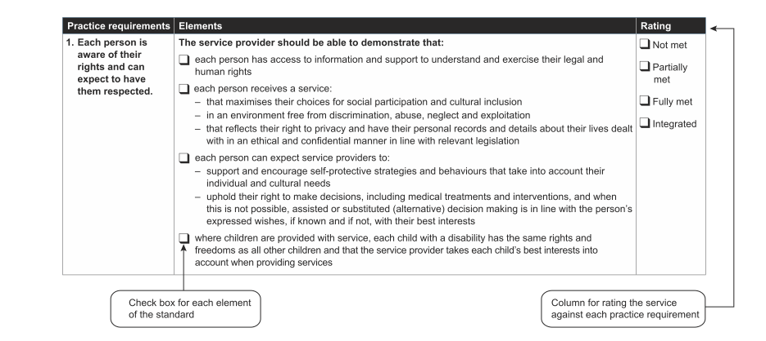

The evidence checklists: There is an evidence checklist for each standard, showing some of the main ways the service could demonstrate how it is meeting the standard.

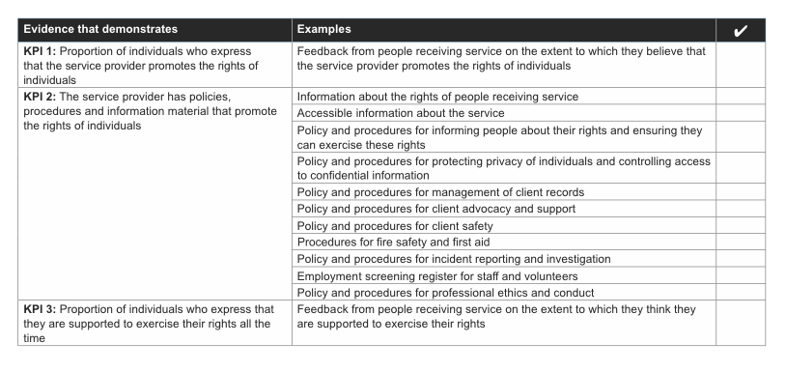

3. Recording template: There is a single template at the end that you can use to record the results of the self-assessment and to
document an action plan.

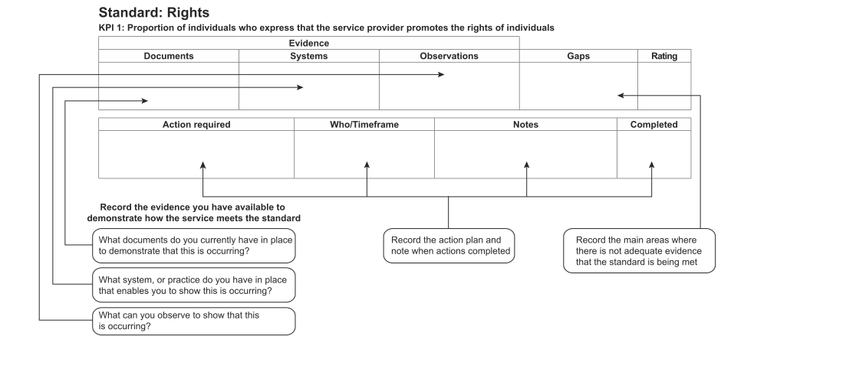

Standard 1: Rights

Each person receives a service that promotes and respects their legal and human rights and enables them to exercise choice like everyone else in the community

Practice requirements

Each person is aware of their rights and can expect to have them respected.

Elements

The service provider should be able to demonstrate that:

each person has access to information and support to understand and exercise their legal and human rights

each person receives a service:

that maximises their choices for social participation and cultural inclusion

in an environment free from discrimination, abuse, neglect and exploitation

that reflects their right to privacy and have their personal records and details about their lives dealt with in an ethical and confidential manner in line with relevant legislation

each person can expect service providers to:

support and encourage self-protective strategies and behaviours that take into account their individual and cultural needs

uphold their right to make decisions, including medical treatments and interventions, and when this is not possible, assisted or substituted (alternative) decision making is in line with the person’s expressed wishes, if known and if not, with their best interests

where children are provided with service, each child with a disability has the same rights and freedoms as all other children and that the service provider takes each child’s best interests into account when providing services

Rate your service against this practice requirement:

Not met, Partially met, Fully met, Integrated

Practice requirements

Service providers are to uphold and promote the legal and human rights of each person

Elements

The service provider should be able to demonstrate that:

services are provided in an environment free from discrimination, financial, sexual, physical and emotional abuse, neglect and exploitation

the service provider:

– encourages and supports access to advocacy services by people with a disability to promote their rights, interests and wellbeing

– gains consent from each person with a disability or their person responsible or legal representative for medical treatments and interventions

– provides opportunities for people with a disability to participate in the development and review of organisational policy and processes that promote strategies for equality and upholding human rights

– takes into account individual choice and the rights of each person and acts in their best interests in relation to nutritional and behaviour management practices in line with relevant legislation, convention, policies and practices

– has knowledge and skills to implement reporting processes on incidents of alleged or known discrimination, abuse, neglect or exploitation and knows how to notify the relevant external authorities

– offers appropriate support to the person and their family or carer when they raise or pursue allegations of discrimination, abuse, neglect or exploitation.

Rate your service against this practice requirement:

Not met, Partially met, Fully met, Integrated
Evidence Guide: Rights

Rights deals with the way in which the organisation promotes and respects the legal and human rights of people receiving services and the way in which it supports them to participate fully in their community.

Policies and procedures should be in place to ensure people receiving services can participate safely in all activities, free from discrimination, abuse, neglect and exploitation.

Personal information about people receiving services is owned by them and as such there should be clear procedures for gaining consent for sharing information, as well as procedures in place for individuals wanting to access their own records.

What you should consider as evidence:
The following are examples of the types of evidence that you should consider using to demonstrate how the service is meeting this standard. This list is not prescriptive or all inclusive and your organisation may have other types of evidence to demonstrate that it meets the requirements.

Evidence that demonstrates

KPI 1: Proportion of individuals who express that the service provider promotes the rights of individuals

Example

Feedback from people receiving service on the extent to which they believe that the service provider promotes the rights of individuals

KPI 2: The service provider has policies, procedures and information material that promote the rights of individuals

Examples

Information about the rights of people receiving service

Accessible information about the service

Policy and procedures for informing people about their rights and ensuring they can exercise these rights

Policy and procedures for protecting privacy of individuals and controlling access to confidential information

Policy and procedures for management of client records

Policy and procedures for client advocacy and support

Policy and procedures for client safety

Procedures for fire safety and first aid

Policy and procedures for incident reporting and investigation

Employment screening register for staff and volunteers

Policy and procedures for professional ethics and conduct

KPI 3: Proportion of individuals who express that they are supported to exercise their rights all the time

Example

Feedback from people receiving service on the extent to which they think they are supported to exercise their rights

Standard 2: Participation and Inclusion

Each person is encouraged and supported to contribute to social and civic life in their communities in the way they choose.

Practice requirements

Each person is actively encouraged and supported to participate in their community In ways that are important to them

Elements

The service provider should be able to demonstrate that:

each person is supported to make decisions about how they connect with their chosen community, respectful of their choices and plans including work, learning, leisure and their social lives

training and support is provided to staff and volunteers so workers understand, respect and act on the interests and skill development of people with a disability over time

they work with people with a disability and their community to promote opportunities and support their active and meaningful participation

they, with the consent of the person with a disability, work with an individual’s family, carer, significant other or advocate to promote their connection, inclusion and participation in the manner they choose

for people exiting the criminal justice system, they actively support the person to develop their interests and activities in ways that consider the rights and welfare of the broader community.

Rate your service against this practice requirement:

Not met, Partially met, Fully met, Integrated

Practice requirements

Service providers develop connections with the community to promote opportunities for active and meaningful participation

Elements

The service provider should be able to demonstrate that they:

actively seek information about other supports and services in their local community to enable people with a disability to achieve their goals and to minimise barriers to participation

ensure that staff and volunteers model respectful and inclusive behaviour when supporting people in their community as a way of promoting the uniqueness of each individual

develop ways to maintain and further develop their local connections so that options for people with a disability to be included and valued are increased over time

actively seek connections with the community for people exiting the criminal justice system.

Rate your service against this practice requirement:

Not met, Partially met, Fully met, Integrated

Evidence Guide: Participation and Inclusion

Participation deals with the way in which the service provider supports the participation of people receiving services and promotes their active involvement, connection with and inclusion in their chosen communities.

Service providers have a responsibility to train their staff to support the active participation of people receiving services. Working cooperatively with other service providers and with the broader community enables service providers to effectively increase the options and opportunities for people with a disability.

What you should consider as evidence:
The following are examples of the types of evidence that you should consider using to demonstrate how the service is meeting this standard. This list is not prescriptive or all inclusive and your organisation may have other types of evidence to demonstrate that it meets the requirements.

Evidence that demonstrates

KPI 4: The service provider has programs and strategies that promote and build community participation opportunities and create and develop community networks

Examples

Documented strategies, procedures, programs and activities for supporting clients to access community services and facilities

Policy and procedures for supporting client participation and involvement in the service

Information about supports and community participation opportunities provided

Records in individual plans of community participation opportunities accessed by individuals

Staff training programs or material addressing participation in community activities

Feedback from staff, individuals and family/friends/carers regarding community participation

Evidence that demonstrates

KPI 5: Proportion of individuals who express that the service provider promotes and encourages participation and inclusion in the community and works with individuals to create opportunities for building community networks that are aligned to their personal goals

Example

Feedback from people receiving service on the extent to which the service provider promotes and encourages participation and inclusion in the community

Evidence that demonstrates

KPI 6: Proportion of individuals who express that they are satisfied with their level of community participation and inclusion

Example

Feedback from people receiving service on the extent to which they are satisfied with their level of community participation and inclusion

Standard 3: Individual Outcomes

Each person is supported to exercise choice and control over the design and delivery of their supports and services.

Practice requirements

Service providers maximise person centred decision making

Elements

The service provider should be able to demonstrate that they:

respect the right of each person to be at the centre of decision making and to have responsibility, as much as possible, for each decision which affects them

support each person to determine the involvement of their family, carers and advocates in planning and decision making processes

respect the views of family and carers in planning and decision making processes. The person with a disability has the final say in the process

ensure staff and volunteers respond in innovative and flexible ways to each person’s need for decision support which reflect their individual and cultural needs

make every effort to enable a person to make a decision or assist families, carers and advocates to come to an agreement before a substitute decision maker is engaged.

Rate your service against this practice requirement:

Not met, Partially met, Fully met, Integrated

Practice requirements

Service providers undertake person centred approaches to planning to enable each person to achieve their individual outcomes

Elements

The service provider should be able to demonstrate that they:

work together with the person to develop and implement a plan that identifies and builds on the person’s strengths, aspirations and goals. Plans should draw on broader family, cultural and religious networks and community organisations

support each person, and (when necessary with consent) their family, carer or advocate to develop, review, assess and adjust their plan as their circumstances or goals change

recognise the importance of risk taking and enable each person to assess the benefits and risks of each option available to them and trial approaches even if they are not in agreement

work with other organisations and community groups to expand the range of service options available in their community

regularly review their person centred approaches to ensure the organisation has the capacity and capability to deliver flexible and responsive supports and services that meet individual needs and expectations.

Rate your service against this practice requirement:

Not met, Partially met, Fully met, Integrated
Evidence Guide: Individual Outcomes

Individual outcomes deals with the way in which the service provider promotes and delivers person centred supports and services that are flexible and responsive. The assistance provided ensures people receiving services are in control of the services they receive. It also, in accordance with their wishes, supports family, carers and advocates to be involved in the decision making process.

Plans should build on the strengths of the person receiving the service, identifying personal goals and delivering services that meet their needs and expectations. Plans should draw on broader family, cultural and religious networks and community organisations.

Service providers should support people receiving services to make decisions on the options available, assisting them to make an informed choice by working with them to assess the benefits and risks of each option.

What you should consider as evidence:

The following are examples of the types of evidence that you should consider using to demonstrate how the service is meeting this standard. This list is not prescriptive or all inclusive and your organisation may have other types of evidence to demonstrate that it meets the requirements.

Evidence that demonstrates

KPI 7: Proportion of individuals who feel that the service provider encourages them to set goals that align with their personal needs and whole of life aspirational goals, and assists in identifying opportunities in the planning process to meet these goals

Example

Feedback from people receiving service on the extent to which they service provider has encouraged them to set goals and identify opportunities to meet those goals and to identify opportunities to meet these goals

KPI 8: Proportion of individuals who express that the service provider adopts a person centred approach in service delivery, and assists the individual to achieve their personal goals which includes encouraging the involvement of families, friends and advocates in line with the wishes and consent of the individual

Examples

Feedback from people receiving service on the extent to which the service provider adopts a person centred approach and assists individuals to achieve their personal goals

Feedback from staff, individuals and family/friends/carers on their involvement in the individuals’ achievement of their personal goals and the whether they believe that the service is assisting people to achieve those goals and advocates in line with their wishes

Evidence that demonstrates

KPI 9: Proportion of individuals who have an individual plan that reflects their current goals and aspirations and express that they are working towards achieving those goals

Examples

Policy and procedures for individual planning and plan reviews

Policy and procedures for client decision making and choice, participation and involvement

Records of individual plans that reflect the goals and aspirations of individuals

Documented referral procedures

Documented procedures on client information exchange

Documented procedures for shared case management

Feedback from individuals on the extent to which individual plans are assisting them achieve goals

Standard 4: Feedback and Complaints

When a person wants to make a complaint, the service provider will make sure the person’s views are respected, that they are informed as the complaint is dealt with, and have the opportunity to be involved in the resolution process.

Practice requirements

Each person is treated fairly by the service provider when making a complaint

Elements

The service provider should be able to demonstrate that they:

inform each person of their right to complain and work with the person, their families and carer to try and resolve the issue

provide a safe environment for each person to make a complaint

ensure that there are no negative consequences or retribution for any person who makes a complaint

support participation in the complaint handling process of any person wanting to make a complaint and work with the person to identify the desired goal

treat each person making a complaint in a manner that protects their privacy and respects confidentiality

are committed to and provide fair and timely resolution of complaints

keep each person informed at all stages of the decision making process concerning their complaint and the reasons for those decisions

inform each person of their right to complain to an external body.

Rate your service against this practice requirement:

Not met, Partially met, Fully met, Integrated

Practice requirements

Each person is provided with information and support to make a complaint

Elements

The service provider should be able to demonstrate that each person:

has continuous and easy access to meaningful and culturally relevant information about the service provider’s complaint policy and processes

has the opportunity to have a chosen support person such as an advocate to assist or represent them during the process

making a complaint is supported by the service provider, in a way which reflects their individual, cultural and linguistic needs to assist them to understand and participate in the complaint handling process

determines how, when and where the complaint will be made

has the opportunity to nominate the person they want at the service as the key contact regarding the complaint.

Rate your service against this practice requirement:

Not met, Partially met, Fully met, Integrated

Practice requirements

Each service provider has the capacity and capability to handle and manage complaints

Elements

The service provider should be able to demonstrate that they:

have a written complaints policy and associated processes which reflect relevant legislation, standards and sector policy

ensure that policies and processes include ways of responding to the cultural and linguistic needs of individuals

ensure that staff and volunteers are trained in complaint handling and demonstrate understanding and capacity to implement complaint handling

record and analyse trends from complaints to drive organisational policy development and continuous improvement

support each person to participate in the review and development of local complaint handling policy and processes and report outcomes to them and their families, carers or advocates

include a standing agenda item on complaint handling in Board and/or management committee meetings should, with trends presented and implications for service planning discussed

are aware that some complaints need to be managed in a particular way, either because the person making a complaint has specific rights of review or because the complaint includes allegations that must be reported to an external body. For example, criminal allegations should be reported to the police

inform each person of their right to make a complaint (where relevant) to the Ombudsman about the provision of a service by a service provider under the Community Services (Complaints, Review and Monitoring) Act 1993 (NSW).

Rate your service against this practice requirement:

Not met, Partially met, Fully met, Integrated
Evidence Guide: Feedback and Complaints

Feedback and complaints deals with the way in which the service provider manages complaints, including the way learning from complaints investigations inform service improvement.

Service providers should provide clear information to people receiving services regarding how to make a complaint, so that each person is able to make a complaint and be fully involved in the complaint resolution process. The complaint management process should take into consideration the person’s individual and cultural needs.

Service providers should be able to demonstrate how they have used complaints information to inform service planning and put in place strategies to address any areas requiring change at an individual or organisational level.

What you should consider as evidence:
The following are examples of the types of evidence that you should consider using to demonstrate how the service is meeting this standard. This list is not prescriptive or all inclusive and your organisation may have other types of evidence to demonstrate that it meets the requirements.

Evidence that demonstrates

KPI 10: The service provider has an accessible complaints mechanism and record keeping systems in place to deal with complaints in a timely and effective manner

Examples

Policy and procedures for receiving, recording, managing and reporting complaints

Information material for service users on complaints procedures

Complaints register

Staff training on encouraging and capturing feedback and handling complaints

Summary data on feedback and complaints (for example, results of collection of feedback, numbers of complaints received, proportion resolved)

Feedback from staff, individuals and family/friends/carers on the effectiveness of the complaints handling process

Evidence that demonstrates

KPI 11: Proportion of individuals that demonstrate understanding of the complaints procedure and express that they would make a complaint if and when the need arises

Example

Feedback from people receiving service on the extent to which they understand the complaints process and their willingness to use it if needed

Evidence that demonstrates

KPI 12: Proportion of individuals who express that their complaint was addressed effectively in any complaints process they were involved in (as a portion of those participants who had participated in any complaints process)

Example

Feedback from people who have made a complaint on the extent to which their issue was addressed effectively

Standard 5: Service Access

Each person is assisted to access the supports and services they need to live the life they choose.

Practice requirements

Service providers make information available about their services

Elements

The service provider should be able to demonstrate that they:

are both proactive and responsive in providing people with a disability, their families and carers information about the features and capacity of the services they offer

provide information about their services in formats that can be readily accessed and easily understood by the diverse mix of people within their community

use communication strategies that enable people with cognitive and/or sensory needs and diverse cultural styles to know how to access the service.

Rate your service against this practice requirement:

Not met, Partially met, Fully met, Integrated

Practice requirements

Service providers have clearly defined processes to access services

Elements

The service provider should be able to demonstrate that they:

develop and apply easy to understand, consistent and transparent access processes so that each person is treated fairly and according to their assessed need

regularly review their information, policies and practices for service access in consultation with people with a disability, their families and carers to identify and minimise barriers that may impact on a person’s fair and equal access to services.

Rate your service against this practice requirement:

Not met, Partially met, Fully met, Integrated

Practice requirements

Service providers work with other organisations to increase each person’s support options

Elements

The service provider should be able to demonstrate that they:

understand the broad range of supports and services available to meet the needs of people with a disability, their families and carers in the community

work with local community and other mainstream and specialist organisations to maintain community engagement and referral networks

provide information and support to the person when recommending or

Rate your service against this practice requirement:

Not met, Partially met, Fully met, Integrated

Evidence Guide: Service Access

Service access deals with the way in which the service provider assists clients to access the supports and services they want and need to live their life the way in which they choose.

Service providers should ensure they make information about their services publicly available and that there are clearly defined, transparent processes for accessing services.

Service providers should maintain awareness of the broad range of local community services and organisations to enable them to effectively refer people needing services and connect them with appropriate services.

What you should consider as evidence:
The following are examples of the types of evidence that you should consider using to demonstrate how the service is meeting this standard. This list is not prescriptive or all inclusive and your organisation may have other types of evidence to demonstrate that it meets the requirements.

Evidence that demonstrates

KPI 13: The service provider provides accessible information to inform individuals of the types and quality of services and supports that are available and how individuals can access and exit services

Examples

Information material on services in accessible formats

Organisational plans identifying access and equity strategies

Policy and procedures for ensuring ease and equity of access to services

Policy and procedures for intake and referral

Documented criteria and procedures for service exit and/or termination

Staff training on types and quality of services and supports available and on access and exit procedures

Feedback from staff, individuals and family/friends/carers on the effectiveness of access and exit procedures

Evidence that demonstrates

KPI 14: Proportion of individuals who express that they are informed of and understand the range of services and supports that are available to them to meet their individual needs and goals and are supported in making choices

Example

Feedback from people seeking or receiving service on the extent to which they understand the range of services and supports available

Evidence that demonstrates

KPI 15: Proportion of individuals who express that they receive access to services and supports that meet their individual needs (or were otherwise provided with referral services and supported through the referral process)

Example

Feedback from people on the extent to which they received access to services and supports that met their individual needs

Standard 6: Service Management

Service providers are well managed and have strong and effective governance to deliver positive outcomes for the people they support.

Practice requirements

Each person receives quality services which are effectively and efficiently governed

Elements

The service provider should be able to demonstrate that the corporate governance body of an organisation:

is comprised of members who possess or can acquire appropriate knowledge, skills and training to fulfil all responsibilities which are clearly defined, documented and disclosed

is equipped and fulfils all responsibilities for strategic planning and developing visionary direction for the organisation based on person centred approaches and future industry needs

is able to exercise objective and independent judgement on corporate affairs which is separate to decision making on operational matters

is accountable to stakeholders and demonstrates high ethical standards acting in their best interests

monitors the effectiveness of the organisation’s governance policies and practices and makes changes as needed

ensures the integrity of the organisation’s accounting and financial reporting systems and that appropriate systems of control are in place for risk management, financial and operational control (including fire safety and appropriate insurance), and compliance with legislation and funding requirements

ensures the organisation has a quality management system and internal controls are in place to comply with relevant standards

uses feedback from stakeholders and the community to inform and develop continuous improvement strategies

regularly reviews its policies to reflect contemporary practice and feedback from people with a disability and other key stakeholders

recruits, supports and monitors senior management positions in line with the vision and values of the organisation and probity requirements

has strategies in place for communication with staff to promote continuous improvement and a collaborative, responsive organisation.

Rate your service against this practice requirement:

Not met, Partially met, Fully met, Integrated

Practice requirements

Each person receives quality services that are well managed and delivered by skilled staff with the right values, attitudes, goals and experience

Elements

The service provider should be able to demonstrate that they:

have written policies and associated processes which reflect relevant legislation, standards, funding requirements and sector policy that are accessible to all stakeholders

have processes to monitor compliance with relevant legislation and policy and to continuously improve organisational performance

encourage and support people with a disability, their families and carers to participate in the planning, management and evaluation of the service

inform stakeholders how feedback has been used to improve service management and delivery

have a workforce planning and recruitment strategy in place to ensure the organisation has a skilled, engaged and responsive workforce

have processes in place for succession planning of leadership staff and other key positions

have recruitment practices that meet all probity requirements and ensure that the right workforce is recruited and

maintained to deliver the range of services provided by the organisation to meet service delivery outcomes

provide regular staff and volunteer training, support and supervision to flexibly meet the needs of people they support

create and maintain accessible and safe physical environments in accordance with all fire safety requirements and occupational health and safety legislative and policy requirements

implement the organisation’s strategic and business plans utilising good practices including community engagement initiatives.

Rate your service against this practice requirement:

Not met, Partially met, Fully met, Integrated

Evidence Guide: Service Management

Service management deals with the governance and management structures within organisations. For service providers to deliver quality services, they must have clearly defined governance and management frameworks, strong internal controls in place and a commitment to continuous quality improvement.

Service providers also need to have appropriately trained staff who are supported to deliver quality services.

Gathering ongoing feedback from people receiving services and other stakeholders, and considering this information in service planning ensures that service development and delivery is continually improving and remains responsive to people’s needs.

What you should consider as evidence:
The following are examples of the types of evidence that you should consider using to demonstrate how the service is meeting this standard. This list is not prescriptive or all inclusive and your organisation may have other types of evidence to demonstrate that it meets the requirements.

Evidence that demonstrates

KPI 16: The service provider has good governance, management and quality processes in place which includes stakeholder consultation and a formal continuous improvement strategy across all aspects of service delivery

Examples

Organisational chart showing the structure and reporting lines

Documents delegations of decision making and authority

Policy and procedures for senior staff positions, including succession planning

Policy and procedures for financial management and planning, record keeping, budget management and monitoring

Policy and procedures for risk management

Policy and procedures for internal reporting

Policy and procedures for human resource management including recruitment, selection and induction for both paid and volunteer roles

Policy and procedures for client feedback and stakeholder consultation

Policy and procedures for interagency collaboration

Compliance register

Organisational business planning and strategies

Organisational continuous improvement plan and quality improvement register

Staff training plans and programs

Feedback from staff, individuals and family/friends/carers on service management

Evidence that demonstrates

KPI 17: Proportion of individuals who express that they receive quality services and supports

Example

Feedback from people receiving service on the extent to which they have received quality services and supports

Evidence that demonstrates

KPI 18: Proportion of individuals who report that the service provider is continuously requesting and analysing feedback and collaborating with individuals and stakeholders to improve the services and supports.

Example

Feedback from people receiving service on the extent to which they have been engaged in providing ingoing feedback that informs service improvement

Workbook: Recording Template

There is a template for each Standard that can be used to record;

Evidence (Documents, Systems, Observation)

Gaps

Rating

Action required

Who/timeframe

Notes Completed

Standard | KPIs | Evidence |  |  | Gaps | Rating | Action required | Who/  timeframe | Notes | Completed
 |  | Documents | Systems | Observations
1. 1. Rights | KPI 1: Proportion of individuals who express that the service provider promotes the rights of individuals
 | KPI 2: The service provider has policies, procedures and information material that promote the rights of individuals
 | KPI 3: Proportion of individuals who express that they are supported to exercise their rights all the time

Standard | KPIs | Evidence |  |  | Gaps | Rating | Action required | Who/  timeframe | Notes | Completed
 |  | Documents | Systems | Observations
2. Participation and inclusion | KPI 4: The service provider has programs and strategies that promote and build community participation and engagement opportunities and create and develop community networks
 | KPI 5: Proportion of individuals who express that the service provider promotes and encourages participation and inclusion in the community and works with individuals to create opportunities for building community networks that are aligned to their personal goals
 | KPI 6: Proportion of individuals who express that they are satisfied with their level of community participation and inclusion

Standard | KPIs | Evidence |  |  | Gaps | Rating | Action required | Who/  timeframe | Notes | Completed
 |  | Documents | Systems | Observations
3. Individual outcomes | KPI 7: Proportion of individuals who feel that the service provider encourages them to set goals that align with their personal needs and whole of life aspirational goals, and assists in identifying opportunities in the planning process to meet those goals
 | KPI 8: Proportion of individuals who express that the service provider adopts a person-centred approach in service delivery, and assists the individual to achieve their personal goals which include encouraging the involvement of families, friends and advocates in line with the wishes and consent of the individual
 | KPI 9: Proportion of individuals who have an up to date individual plan and state that they are working towards achieving those goals

Standard | KPIs | Evidence |  |  | Gaps | Rating | Action required | Who/  timeframe | Notes | Completed
 |  | Documents | Systems | Observations
4. Feedback and complaints | KPI 10: The service provider has an accessible complaints mechanism and record keeping systems in place to deal with complaints in a timely and effective manner
 | KPI 11: Proportion of individuals that demonstrate understanding of the complaints procedure and express that they would make a complaint if and when the need arises
 | KPI 12: Proportion of individuals who express that their complaint was addressed effectively in any complaints process they were involved in (as a proportion of those participants who had participated in any complaints process)

Standard | KPIs | Evidence |  |  | Gaps | Rating | Action required | Who/  timeframe | Notes | Completed
 |  | Documents | Systems | Observations
5. Service access | KPI 13: The service provider provides accessible information to inform individuals of the types and quality of services and supports that are available and how individuals can access and exit services
 | KPI 14: Proportion of individuals who express that they are informed of an understand the range of services and supports that are available to them to meet their individual needs and goals and are supported in making choices
 | KPI 15: Proportion of individuals who express that they receive access to services and supports that met their individual needs (or were otherwise provided with referral services and supported through the referral process)

Standard | KPIs | Evidence |  |  | Gaps | Rating | Action required | Who/  timeframe | Notes | Completed
 |  | Documents | Systems | Observations
6. Service management | KPI 16: The service provider has good governance management and quality processes in place which includes stakeholder consultation and a formal continuous improvement strategy across all aspects of service delivery
 | KPI 17: Proportion of individuals who express that they receive quality services and supports
 | KPI 18: Proportion of individuals who report that the service provider is continuously requesting and analysing feedback and collaborating with individuals and stakeholders to improve the services and supports.

Breaking New Ground ABN 21 948 817 923

Bradfield Nyland Group & BNG NGO Services Online February 2013

