Overuse, injury prevention and exercise

booklet for ADEs

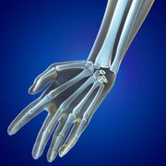
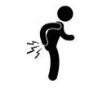

Presented by University of Sydney Physiotherapy Students
Royce Chen, Jemima Lee, Alex Ladomatos
In conjunction with National Disability Services

Table of Contents
1. Introduction 2
2. Carpal Tunnel Syndrome 3
3. Work Related Upper Limb Disorders 5
4. Work Related Shoulder Pain 7
5. Work Related Lower Back Pain 9
6. Observations from Worksite 11
6.1 Observation: Rotation at Work Stations 11
6.2 Observation: Repetitive Fine Motor Application of Fingers 12
6.3 Observation: Suitable Ergonomic Chairs 13
6.4 Observation: Standardised Adequate Rest Periods from work 14
7. General Strategies 15
7.1 Job Rotation 15
7.2 Sit Stand Workstations 17
7.3 Appropriate Seating 19
7.4 Standardised break times 20
8. Exercise Program 21
8.1 Introduction 21
8.2 Wrist Stretch 1 (1 minute) 22
8.3 Wrist Stretch 2 (2 minutes) 23
8.4 Neck Head Circuit (2 minutes) 24
8.5 Shoulder Exercise (2 minutes) 26
8.6 Lower Back Pain Circuit (2 Minutes) 28
8.7 Implementation Process and Programming 30
9. Summary 31
10. References 32

Introduction

The nature of manual tasks inherently present a degree of risk for the individual performing these movements. These risks may be associated with a large variety of factors involving weight lifted, repetitive movements and poor postures. Over time, an accumulation of these poor manual postures and repetitive workloads may lead to musculoskeletal disorders and pain. This results in time loss from work due to injuries, leading to an overall reduction in efficiency of the workforce.

A musculoskeletal disorder, as defined in WHS regulations, is an injury to, or a disease of the musculoskeletal system, whether occurring suddenly or over time.

Occupational overuse syndrome (OOS) is defined as a ‘collective term for a range of conditions in the upper limb and neck region, characterised by discomfort or persistent pain in muscles, tendons and other soft tissues, with or without physical manifestations. OOS is usually associated with repetitive movement, sustained or constrained postures and/or forceful movements, aggravated by or related to an occupational setting”

Of particular concern is gradual wear and tear to joints, ligaments, muscles and intervertebral discs caused by repeated or continuous use of the same body parts, including static body positions.

There is a need to minimise these injuries, as they undermine the productivity and output of the workforce. Not only is there the individual time loss due to injury, there is also the written claims process and incident reports that undermine overall productivity.

These can be addressed through general strategies and a comprehensive exercise program involving stretching and range of motion activities.

As such, the purpose of this report is to
- Identify common occupational overuse syndromes (OOS), understand mechanisms, symptoms and summarise epidemiological data regarding conditions
- Suggest general strategies to reduce OOS, including seating, breaks and rotation
- Provide an exercise program to both treat pre-existing injuries and prevent further onset of new ones
- Provide instructions for implementation of the exercise program into daily scheduling

The primary outcome would be to reduce injuries in the workforce, increasing overall quality of life for workers and overall enhancing workforce productivity to meet production quotas and output more efficiently.

Carpal Tunnel Syndrome

What is Carpal Tunnel Syndrome?

Carpal Tunnel Syndrome (CTS) is a disorder of the hand and wrist originating from nerve compression at the wrist, known as the carpal tunnel. CTS affects approximately 3.8% of general population, and involves the entrapment, or compression, of the median nerve at the wrist joint. Entrapment of the median nerve will result in further inflammation, compressing the nerves even further, leading to a vicious spiral of pain and impaired function.
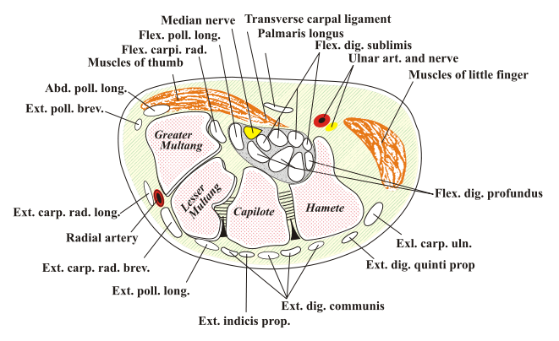
Figure 2

The areas of concern are highlighted in yellow in Figure 2. These are the nerves that become compressed in the carpal tunnel and lead to the development of this syndrome.

How does carpal tunnel syndrome develop?

The median nerve travels through the wrist joint in an area known as the carpal tunnel, a space between the bones of the hand and wrist. A common mechanism for development of CTS is repetitive overuse of the wrist leading to increased pressure on the median nerve, generally caused by the nerve becoming pressed or squeezed at the wrist, a phenomenon known as biomechanical overload.

What are the causes of carpal tunnel syndrome?

The most common cause of carpal tunnel syndrome is overuse injury - and the tendons in the carpal tunnel become irritated by sustained awkward postures or repetitive hand movements. Some other causes of CTS are arthritis, pregnancy and wrist fractures.

What symptoms are there with Carpal Tunnel Syndrome?

Some of the most common symptoms of CTS include:
- Numbness - or the loss of sensation over their hand
- Strong sharp darting pains from the wrist
- Radiating pain into the arm and shoulder
- Weakness of the hand

The condition is more common in females than males (9% prevalence vs 6%) and occurs in all age groups. Data from the UK states the median number of days away from work due to CTS at 27 days.

The symptoms of note would be the pain, numbness and weakness. These are the main features that will prevent an individual from performing manual handling tasks, and detract from their efficiency within a process line or their work.

Risk factors of Carpal Tunnel Syndrome

- Women between the ages of 40 and 60 are at the highest risk
- People with arthritis
- People who use their hands repetitively in their day to day activities, such as typists or in particular assembly line workers

What treatment choices are there?

- Surgical decompression - a carpal tunnel release involving cutting a wrist ligament to increase the space in the carpal tunnel hence reducing pressure within the joint. Approximately 70-90% of patients have good to excellent long term outcomes following CTR
- Conservative - use of corticosteroids, non steroidal anti inflammatory drugs, ultrasound and immobilization.

Prevention of Carpal Tunnel

Due to a large time loss due to injury from CTS, it would be best to approach preventative and conservative exercise to limit any further aggravation of the carpal tunnel. A variety of strategies can be incorporated such as
- exercises to target the prevention of CTS
- Ergonomic setup and environment to prevent poor postures
- Job rotation to prevent repetitive tasks
- Break times to relax worked muscles

Work Related Upper Limb Disorders

What are work related upper limb disorders?

Work related upper limb disorders (WRULD) covers a wide variety of disorders such as

Neck strain injury - onset of neck strain and neck pain generally caused by injuries to the muscles and tendons that support and move the head and neck.

Occupational cramps - cramps or spasms of certain muscles of the hand and of the forearm, often presenting itself with fine motor tasks such as writing or playing an instrument

Occupational myalgia - muscle pain, a symptom of many disorders, commonly presenting again with fine motor tasks and repetitive use

Repetitive strain Injury - an injury to the muscles or nervous systems that may be caused by repetitive tasks, forceful exertion, vibration or sustained and awkward positions

Trigger Finger - a condition affecting the fingers and the thumb, caused by inflammation of the tendons in the hand and fingers and repetitive hand and thumb movements

What are the symptoms of work related upper limb disorders?

All of these WRULDs are characterised by pain in the muscles, tendons and structures. Common symptoms include:

Pain in the fingers, wrists arms and shoulders

Stiffness

Pins and needles, tingling

Numbness

Swelling

Loss of strength

Cramps

How do work related upper limb disorders develop?

The three main causes of all of these conditions can be categorised into

Static Muscle Loading - muscular activity focusing on holding an object or maintaining a certain posture with little to no movement. This causes a lack of circulation, accumulation of waste product and aching or discomfort.

Overuse and repetition - overuse of specific muscles and repetition can carry the risk of straining tissues beyond their normal capacity. Any repetitive task performed continuously without sufficient breaks or changes in activity will place demands on specific structures and result in a risk of injury

Stress - Stress will cause increased muscle tension and sensitises the nervous system, leading to an increased perception of pain

What are the common causes and risk factors for WRULD’s?

Some of the common causes include:
- Repetitive working at a poorly set up workstation that has not been adjusted correctly for the individual
- Using and lifting equipment that is too heavy
- Using and lifting equipment that is the wrong size
- Using vibrating equipment
- Tasks that demands grip or application of pressure for a long time
- Doing repetitive movements
- Doing the same task for a long time without breaks

What treatment choices are there?

Treatment for WRULD is generally sought after when the pain is persistent even at rest, however early intervention produces the best results. Treatment involves a combination of
- Hands on physiotherapy techniques
- Exercises
- Relaxation and pain control
- Good workstation ergonomics
- Advice on posture and work pacing

It is to be noted that rest alone does not address the problem, and may only settle the symptoms temporarily.

How to prevent WRULDs from happening?

It would be preferential to set up the working environment so that the WRULD’s do not develop, and this can be addressed through
- Proper work station ergonomics
- Rest Intervals
- Suitable equipment and work loads

Work Related Shoulder Pain

What is Work Related Shoulder Pain?

Work related shoulder pain covers a broad spectrum of shoulder injuries that are experienced as a result from work. A few of the work related shoulder issues are:
- Rotator Cuff Injuries - an injury to the rotator cuff muscles located inside the shoulder, leading to pain, decreased range of motion and lack of shoulder stability
- Nerve Impairment - occurs when the space allowing nerves to travel within the shoulder are trapped, leading to loss of sensation and weakness
- Frozen Shoulder - loss of range of motion within the shoulder joint
- Shoulder Impingement - any disruption to the space within the shoulder joint that will limit movement as well as bring on pain
- Tendonitis - inflammation of muscular tendons leading to increased pain and decreased movements
- Overuse injuries - injuries characterised by pain usually brought on by poor work postures and prolonged static loading of the muscles

The shoulder joint is a complex joint allowing a lot of movement, however this leads itself to it being more prone to instability and joint pathologies that have the potential to remove workers from work due to pain.

What are the symptoms of work related shoulder pain?

Pain is the most common symptom that is noticed after or during a work related shoulder injury. Some other symptoms include:

Decreased range of motion

Numbness

Tingling

Stiffness of the shoulder joint

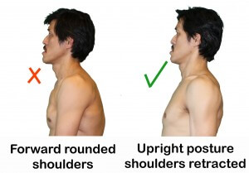
How do work related shoulder injuries develop and what are the causes?
- Shoulder injuries can be caused by repetitive motions, heaving lifting or repetitive everyday motions and activities that have been poorly set up and conducted with poor postures.
- For the shoulder girdle, a common problem is poor upper back posture, leading the shoulders to roll forwards as depicted in figure 3

How to prevent shoulder pain from developing?

Preventative measures include

Ergonomic setup to improve posture

Adequate rest times to decrease muscle load

Adequate job rotation to prevent overload of muscle

Work Related Lower Back Pain

What is work related lower back pain?

Lower back pain linked to workplace accounts for a third of all work-related disability worldwide.

Work related low back disorders covers both low back pain as well as low back injuries.

The lower back has a wide number of sites that could potentially become irritated and lead to pain, such as:
- Large nerve roots in the lower back that go to the legs
- Smaller nerves that supply the lower back
- Muscles in the lower back that help to straighten out the spine
- Bones, ligaments and intervertebral discs are all located in the back

An irritation or problem with any of these structures can cause lower back pain.

What are the symptoms of work related lower back pain?

Symptoms or work related lower back pain and disorders can include, but are not limited to,
- Pain that tends to be achy, dull and constant
- Difficulty moving, severe enough to prevent walking or standing
- Pain that moves to the groin, buttock or upper thigh
- Painful and severe muscle spasms
- Local soreness

In most cases patients make a full recovery from lower back pain in a time from between 6 weeks to 12 months, adding up to a very large amount of lost time from work.

How does work related back pain develop and what are the causes?

Lower back pain is very common across all types of industries and jobs, however work related risk factors include
- Heavy physical work
- Lifting and handling of loads
- Awkward postures including, bending, twisting and prolonged static postures
- Poor work organisation
- Low job content

What strategies are there to prevent work related lower back pain

Strategies to prevent low back disorders can include the workplace as well as outside of it. It is hoped that preventative measures will be taken and implemented prior to development of lower back pain. In terms of the workplace, preventative strategies to decrease the incidence of lower back pain include:
- Reduction of physical demands - offloading some of the heavy lifting to machinery
- Improvements in work organisation - avoiding prolonged work including awkward positions and static postures
- Adequate job rotation and rest times
- Exercise to support the back muscles and abdominal bracing, increasing core stability

Observations from Worksite

To note, these are merely observations of work practices at an ADE Worksite from an ergonomic and work health safety standpoint, with information on potential ways these could lead to injuries in the long term. These are by no means criticisms of operational procedures.

Observation: Rotation at Work Stations

Target Audience: Production Managers, Warehouse Managers, Floor Supervisors

Alert Severity: This situation has potential for incident to occur long term

Alert Outline:

Through conversations with key personnel on the production floor, it was revealed that some employees working on the production line are given the same role in the process chain, therefore performing the same manual task over an extended period of time. For some employees, this may be unavoidable due to their capabilities, and for others it may be challenging to learn of perform another task.

Even with proper seating, chairs, tilted tables for ergonomic comfort, employees are still at risk of occupational overuse syndrome, and could very well manifest in conditions such as carpal tunnel, and back or shoulder pain.

Potential Consequences:

The problem is that repetitive use of the same muscle groups, regardless of posture and ergonomics, is associated with a much higher incidence of overuse injuries.

Hagberg, Morgenstern and Kelsh (1992) reported epidemiological studies on carpal tunnel syndrome. Repetitive movements is associated with a 50-90% increased occurrence of carpal tunnel syndrome, a condition in the upper limb, specifically the median nerve at the carpal tunnel or wrist.

Observation: Repetitive Fine Motor Application of Fingers
Target Audience: Production Managers, Warehouse Managers, Floor Supervisors

Alert Severity: This situation has potential for incident to occur long term

Alert Outline:

During our site visit it was noted some packaging tasks require high levels of fine motor skills and finger dexterity. The fine motor skills of the fingers included precise finger movements co-ordinated with precise wrist, elbow and shoulder movements and positioning.

Another job of note and concern is the label sticking and repackaging. The job involves a lot of fine pinching, gripping and hand eye co-ordination, and has the potential to lead to overuse injuries in the long term.

It is understood that due to the nature of the job, such tasks are unavoidable. However efforts can be made to minimise the stress on certain individuals, with more distribution of roles throughout the entire workforce.

Potential Consequences:

The physical and cognitive workload in addition to the repetitive work for hours a day every day places certain employees at a much higher risk of development of injury, ultimately undermining their long term sustainability in the role, increasing time loss due to injury and a long term decrease in productivity.

Observation: Suitable Ergonomic Chairs

Target Audience: Production Managers, Warehouse Managers, Floor Supervisors

Alert Severity: This situation has potential for incident to occur long term

Alert Outline:

Many production line workers do not have access to proper ergonomic chairs, to be used at their workstation. There is a need to ensure every individual placed at the production line has access to an adjustable ergonomic chair, and that they are used correctly. The office chairs that are currently in some parts of production facilities lack adequate lumbar support, and are sometimes non-adjustable for height or the height adjustment is broken.

It is further understood that this may be due to budget constraints, however, it would be an area of major concern and should be seen as a long term investment in the workforce, as important as any other piece of equipment in the production line.

Potential Consequences:

A lack of adjustability of the work chair encourages poor biomechanics, sitting habits, and poor movements as the employees go to reach for objects or general manual handling. Over time, improper biomechanics will lead to lower back pain, further incapacitating them from their usual function and thus their work.

Observation: Standardised Adequate Rest Periods from work

Target Audience: Production Managers, Warehouse Managers, Floor Supervisors

Alert Severity: This situation has potential for incident to occur long term

Alert Outline:

It is observed that standardised adequate rest periods from work are not in place.

Production line workers are often not burdened with pressure regarding meeting production quotas, and are told to work ‘at their own pace,’ with breaks being taken if felt necessary by the workers themselves.

Potential Consequences:

A potential issue that may arise from this system is the potential for imbalance; some employees may take adequate rest periods, however some may also never feel the need to take breaks throughout the day.

General Strategies
This section details some general strategies that can be implemented into the workstations or into the daily routine. General strategies include low cost and efficient modifications, not including exercise, which will be addressed individually in the later section. Each section outlines strategies for implementation

Job Rotation

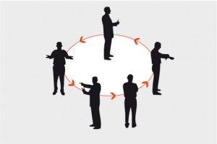
What is Job Rotation?

Job rotation involves rotating jobs between workers where employees are moved between two or more jobs in a planned manner at a set time. The main objective of job rotation is to control and minimise the manual handling risks involved in any one task, minimising risk on one individual

What does Job Rotation reduce?

- Fatigue - both physical fatigue of certain muscle groups as well as mental fatigue and boredom with a task. Fatigue reduces an employee’s ability to perform work safely and effectively. It also reduces alertness, which may lead to errors and an increase in incidents and injuries
- Poor static postures - in rotating between different tasks, employees have to change their body posture and movements - preventing accumulation of poor practices compounded over time
- Long Term Injuries - an accumulation of fatigue and poor static postures over extended periods of time will lead to occupational overuse injuries and result in time loss from work

Benefits of Rotation

- Diversify the employees - this will make the workers more versatile and they will be able to perform a higher variety of tasks and with proficiency
- Reduces employee boredom with their job and certain tasks
- Reduces poor static postures that would otherwise be accumulated throughout the day
- Rotating between jobs will give employees a micro-break throughout the day, allocating a time where exercises can be performed. These exercises are outlined further in this manual
- Decreasing the rate of injuries will ultimately lead to less long term health issues that will prevent an employee from coming to work in the future

Implementation Strategies

- Employees are already split into work stations, however currently remain where they are all working hours doing the same task
- Every hour of work, change the employee at the workstation so that they are doing a new tasks
- For example → manual packer can change to production line sorting defective products

Sit Stand Workstations

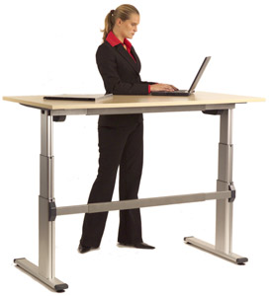
What is a sit stand workstation

A sit stand workstation is a physical workstation to be implemented into a worksite. These workstations can be adjusted in terms of their height, to provide good ergonomics and comfort regardless of whether the employee wishes to sit in an ergonomic chair or stand to work. They are usually used in 2 phases, phase 1 at a low height for sitting and phase 2 in a relatively higher position to support proper upper limb function in standing.

What do sit stand workstations reduce?

- Poor static postures over a period of time - utilising a sit stand workstation ensures employees are transitioning between standing and sitting. When they feel uncomfortable or restless after sitting for a prolonged period, employees should be encouraged to stand up, and bring the workstation up to meet them in height accordingly.
- Overall daily sitting time - not only benefits in the short term. There is considerable evidence to suggest that prolonged sitting is overall detrimental to long term health. This will not manifest immediately in terms of reduced injury rates from work but will improve long term health and sustainability of workers.

Benefits of a Sit Stand Workstation

- Improved postures over a longer time will lead to better overall body movement and health
- Especially in the case of fine motor tasks, a change in posture from sitting to standing will reduce the load on certain muscles, especially helping a hunched forward posture
- Increasing work ergonomics will lead to a decrease in long term overuse injuries and syndromes, improving work efficiency.

Implementation strategies

- Sit stand workstations are fairly costly (close to $1000AUD per unit) and thus if implemented should be placed where they are most cost effective
- Alternatively look at varying the height of work stations so that some require a standing posture.
- Suggestions would be to place these workstation where the workers have the most intense tasks.
- If these workers are able to change their posture and perform the work while standing, their shoulders will be less rounded, and their heads and necks would not be as strained, looking down towards the work.

If these strategies are followed, incidence of shoulder and neck pain should be reduced, as well as any upper limb dysfunction caused by long term loading
Appropriate Seating

What is appropriate seating

Appropriate seating involves use of chairs that have proper back support, and are height adjustable to be tailored to individual heights. A good ergonomic chair should be designed to suit a range of people and needs to be adjustable, have a back rest with firm 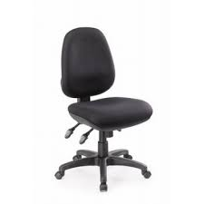lumbar support, have appropriate seat depth, and is appropriately stable. With proper and appropriate use, a well designed chair allows the user to sit in a balanced position
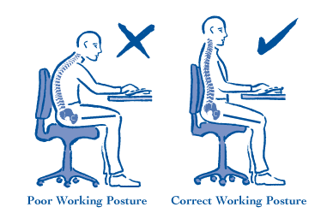
What does appropriate seating reduce?

- Poor seating postures - a good ergonomic chair will encourage a good working posture - as shown in the diagram to the right

Benefits of Appropriate Seating

- Encourages workers to utilise these chairs and have correct working posture
- Good seating ergonomics has been associated with reducing chronic lower back pain
- Good shoulder support with the ergonomic chair will reduce hunched forward posture

Implementation

Phase in the introduction of suitable ergonomic chairs

Provide training and supervision in correct adjustment

Again, suggestions would be to place these where they are of maximum benefit, namely the work involving highly repetitive tasks.

Standardised break times

What this strategy is
Standardised break times involve a designated time slot within the day, perhaps every hour or every 2 hours, where work will stop for a few minutes, and employees will be given a chance to rest. This implementation has been suggested as this will ensure all production line workers will get an appropriate amount of rest, not as they see fit, as has been implemented in the past.

What does this reduce?

- Static postures and a lack of posture change accumulated throughout the day - static postures will lead to long term lower back pain as well as occupational overuse syndrome.
- Reduces boredom and fatigue with work - limiting lapses in concentration due to working constantly over a period of time. These lapses in concentration may cause poor work habits and postures that will lead to injuries

Benefits of Standardised break times

- Reduces the boredom and mental fatigue employees may feel if they are allocated to a certain task and perform it all day without breaks
- Makes sure all employees do get a break and feel as if they can and need to take one, instead of just being told to take one as they see fit
- Standardised break times will lead to less disruption of production lines if a single individual takes a break
- Standardised breaks can be used to implement exercises to reduce the incidence of occupational overuse syndrome

Implementation

Ideally there will be a standardised STOP WORK break every hour
- This break would provide ample time for job rotation as well as exercise program to be implemented
- Breaks last around 5 minutes, giving people time to move around

Exercise Program

Introduction

These suggested exercises are to be conducted whilst at work, and will be led by floor supervisors, done all together as a group. The purpose of these exercises is to restore movements, and improve the flexibility of muscles crossing over the joints. Exercises include a range of moderate strengthening, stretching and range of motion exercises. They are not designed to be intense or vigorous physical activity.

Exercise should not be viewed as a form of treatment once individuals have developed overuse syndrome and pain, it is more of a preventative measure to be implemented into standard operational procedure to prevent occurrence of injury.

If there is persistent pain and other symptoms, it is best to stop doing these exercises, stop work and seek the proper attention for injury.

The specific exercises have been shown as they do not require any specialised equipment, and can be done safely with minimal supervision and instructions

When should these exercises be done?

These recommended exercises should be done around 3 times a day, every day when employees are on the production line. Exercise times should be spread evenly throughout the work day, once in the morning, once prior to lunch and once in between lunch break and finishing time.

A suggested time to implement this into everyday scheduling is into the allocated rest times and rotation times as suggested in General Strategies (page 14,17). This would minimise productivity loss and work output.

General Instructions

- These exercises should not be done in the presence of pain. If pain persists stop exercises immediately
- Breathing should be regulated throughout all of these exercises, and breath should not be held

Wrist Stretch 1 (1 minute)

Description

This is a forearm and wrist stretch done to loosen the wrist joint, restore movement and improve flexibility of the muscles crossing the wrist.

Targeted Muscles and Problems

- Improve wrist mobility and movements
- Avoid carpal tunnel syndrome

Instructions

Start with the forearm supported by a table or a bench, with the wrist and fingers over the edge as depicted in the picture

Slowly bend the wrist forwards (down) until you feel a mild to moderate stretch that can be held pain free for 3 seconds

Slowly bend the wrist backwards (up) until you feel a mild to moderate stretch that can be held pain free for 3 seconds

Repeat steps 2 and 3, 10 times.

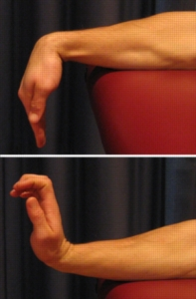

Wrist Stretch 2 (2 minutes)
Description

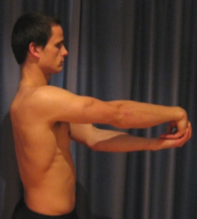
A further wrist and forearm stretch targeted in a standing position. The main aim is again to loosen the joint, restore movement and improve flexibility of the arm and the wrist.

With additional flexibility and fluidity with wrist movements, individuals are less likely to adopt awkward repetitive postures, which leads to further complications.

Targeted Muscles and Problems

- Improve wrist mobility and movements
- Avoid onset of Carpal Tunnel Syndrome

Instructions

- Place one arm straight out in front of you with your elbows straight, wrist straight and fingers facing down towards the floor
- Spread your fingers slightly and use your other hand to apply gentle pressure to the down-facing hand, stretching wrist and fingers as far as you are able to
- When you read the maximum point of flexibility, hold this position for about 20 seconds
- Repeat this action applying gentle pressure to the down facing hand, this time lifting it up towards the ceiling, holding this position for about 20 seconds
- Switch hands and repeat
- Do this 3 times each for both left and right hands.
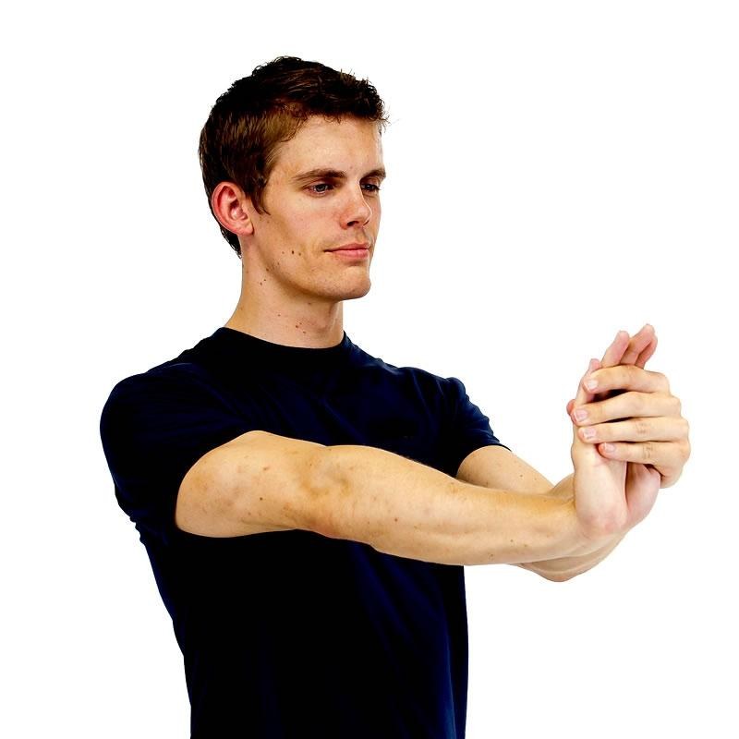
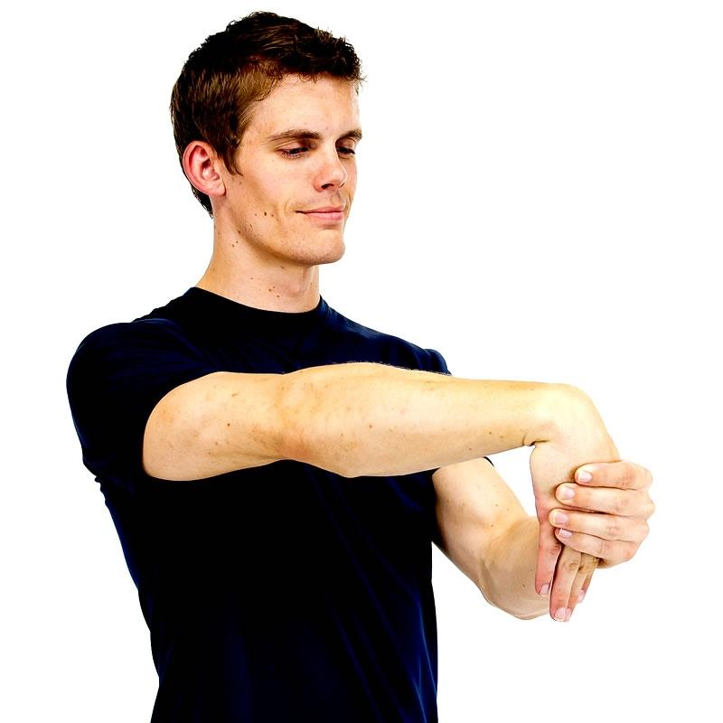

Neck Head Circuit (2 minutes)

Description

The neck and head circuit is a series of exercises and stretches designed to stretch and exercise the neck in all planes of motion. These motions include side to side rotation, lateral flexion, as well as nodding forwards and backwards.

The benefits of this head and neck circuit include
- Lengthening and stretching the neck muscles
- Releasing tightness accumulated due to poor posture

Targeted Muscles and problems

- Targets the muscles around the shoulder and the neck
- Releases tightness associated with poor postures

Instructions

- Sit comfortably, with shoulders relaxed and eyes facing forward. Slowly turn your chin towards your right shoulder, keeping the neck upright. Hold for 20 seconds, repeat the same to the other side.

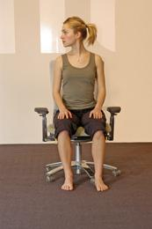

2. Take your right ear down towards the right shoulder, feeling the stretch on the opposite side. Hold for about 20 seconds, repeat the same to the other side.

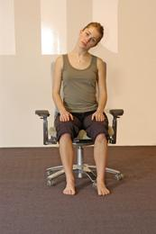

3. Lift your chin up towards the ceiling. Allow the head to drop back as far as comfortable, hold for 20 seconds. Repeat the same bending your chin down to chest
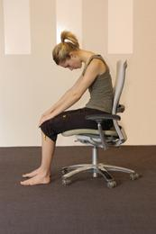

Shoulder Circuit (2 minutes)

Description

Shoulder Rolls involve movements of the shoulder joint in all planes, and can be performed sitting down with no equipment.

The benefits of performing shoulder rolls multiple times a day include

Releases shoulder and neck tension coming from poor work postures

Counteracts shoulders that are hunched forward

Targeted Muscles and Problems

Work related upper limb disorders, particularly shoulder pathologies

Counteract poor postures, particularly hunched over shoulders, placing increased strain on shoulder muscles

Instructions

Inhale and lift the shoulders up and back, rolling them backwards and bringing the shoulder blade down.

Exhale, and reverse them back down to original position, as shown in picture.
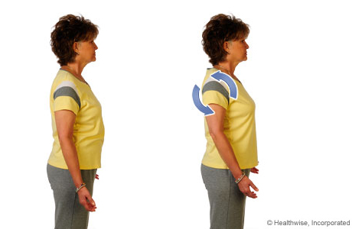

Placing hands on shoulders, bring the elbows in front of the chest, then up to the ceiling, and then down, as depicted in this figure.
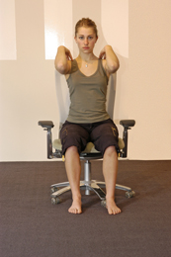

Bring your fingers up towards the side of your shoulders to touch the sides, and then back down, as shown in this figure.

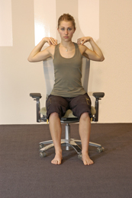
- Repeat steps 1-4 5 times

Lower Back Pain Circuit (2 Minutes)

Description

The purpose of the lower back exercise circuit is to move the lower back, and will prevent lower back pain and flare ups from prolonged postures.

Benefits of doing lower back exercises include

Releases tension in the lower back, and provides adequate blood flow after a long static posture

Elongates the spine and causes the muscles to go through their active range of movement

Desensitises structures around the back that may amplify lower back pain

Targeted Muscles, Structures and Impairments

Primarily targeted at reducing the incidence of work related lower back pain

Instructions

Sitting in the chair, place hands on knees, straighten out the spine and the back of the neck to align eyes facing forward.

Bending forward from the hips and not the upper body, bring chest down to knees.
(bring your bellybutton to your thigh)

Hold for 20 seconds, and then gently come back up into starting position.
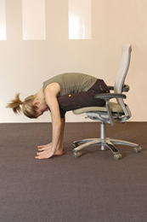
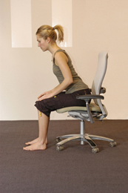

Sitting in the chair, sitting up straight, turn and twist to the right as far as you can, hold for 20 seconds, and repeat with the left.

- Repeat steps 1- 4.

Implementation Process and Programming

Exercise program is to be repeated 3x a day, during designated work break times, as suggested in the general strategies section. Structure of the exercise is as follows:

Timeslot 1 | Timeslot 2 | Timeslot 3
Wrist Stretch 1  Stretch x 10 | Wrist Stretch 1  Stretch x 10 | Wrist Stretch 1  Stretch x 10
Wrist Stretch 2  Stretch both arms x 3 | Wrist Stretch 2  Stretch both arms x 3 | Wrist Stretch 2  Stretch both arms x 3
Neck Head Circuit  Circuit Round x 1 | Neck Head Circuit  Circuit Round x 1 | Neck Head Circuit  Circuit Round x 1
Shoulder Circuit  Circuit Round x 5 | Shoulder Circuit  Circuit Round x 5 | Shoulder Circuit  Circuit Round x 5
Lower Back Circuit  Circuit Round x 2 | Lower Back Circuit  Circuit Round x 2 | Lower Back Circuit  Circuit Round x 2
Total: 10 Minutes | Total 10 Minutes | Total 10 Minutes

These 3 exercise sessions should be done daily, regardless of circumstances. All of these exercises have maximal benefit if they are done consistently, at least a couple of times a day.

These bouts of exercises should be overseen by managers and supervisors, in a sense ‘leading an exercise class.’ The instructions they give should be similar as to the ones depicted in the booklet.

Summary

Occupational Overuse Syndrome is one of the leading causes of time loss from work, and covers a wide range of Worker’s Compensation Claims. These injuries are generally not sustained due to one acute event, instead being the accumulation of poor postures and poor habits over a long period of time.

Occupations and work sites that involve a high degree of manual handling and repetitive tasks increase the risk of developing OOS, and as such, particular strategies need to be implemented into Standard Operation Procedures to decrease the likelihood of these injuries occurring.

This booklet has detailed, summarised and provided implementation strategies for:

Current practices that present a risk for developing OOS

General strategies to decrease the likelihood of development of these conditions such as breaks, rotation, seating and sit stand workstations

An exercise program integrated into the work day to improve work postures, practices and prevent injuries

Further work in the future can be done to evaluate the effectiveness of this program and general strategies, analysing and evaluating:

Implementation success, and barriers to implementation of suggested strategies

A post implementation means of tracking progress, such as an evaluation of total time loss due to injury after a period of 6 months

Compliance with program

References

A guide to work related upper limb disorders. (2016). UNISON. Retrieved 5 May, 2016, from https://www.unison.org.uk/get-help/knowledge/health-and-safety/wrulds-and-rsi/
Australia, S. W. (2011). Hazardous manual tasks: Code of practice. Australian Government-Safe Work Australia.

Bland, J. D. (2007). Treatment of carpal tunnel syndrome. Muscle & nerve, 36(2), 167-171.

Boyle, T., Fritschi, L., Heyworth, J., & Bull, F. (2011). Long-term sedentary work and the risk of subsite-specific colorectal cancer. American journal of epidemiology, 173(10), 1183-1191.

Carpal tunnel syndrome fact sheet. (2016). UNISON. Retrieved 5 May, 2016, from https://www.unison.org.uk/get-help/knowledge/health-and-safety/wrulds-and-rsi/

Hagberg, M., Morgenstern, H., & Kelsh, M. (1992). Impact of occupations and job tasks on the prevalence of carpal tunnel syndrome. Scandinavian journal of work, environment & health, 337-345.

Hsieh, A. T., & Chao, H. Y. (2004). A reassessment of the relationship between job specialization, job rotation and job burnout: example of Taiwan's high-technology industry. The International Journal of Human Resource Management, 15(6), 1108-1123.

Keith, M. W., Masear, V., Amadio, P. C., Andary, M., Barth, R. W., Graham, B., ... & Turkelson, C. M. (2009). Treatment of carpal tunnel syndrome.Journal of the American Academy of Orthopaedic Surgeons, 17(6), 397-405.

Low back pain leading cause of disability: study. (2016). Gordon, S. Retrieved 5 May, 2016, from http://www.webmd.com/back-pain/news/20140325/low-back-pain-leading-cause-of-disability-worldwide-study

National Heart Foundation of Australia (2011) Sitting less for adults
COMCARE Benefits of Movement-Be Upstanding!

Neck exercises. (2016). Retrieved 5 May, 2016, from https://www.stretchnow.com.au/neck-exercise

NIOSH, National Code of Practice for the prevention of Occupational Overuse Syndrome[NOHSC:2013(1994)]

Op De Beeck, R., & Hermans, V. (2000). Work-related low back disorders. European Agency for Safety and Health at Work.

Owen, N., Healy, G. N., Matthews, C. E., & Dunstan, D. W. (2010). Too much sitting: the population-health science of sedentary behavior. Exercise and sport sciences reviews, 38(3), 105.

Soukup, M. G., LÖnn, J., GlomsrÖd, B., BÖ, K., & Larsen, S. (2001). Exercises and education as secondary prevention for recurrent low back pain. Physiotherapy Research International, 6(1), 27-39.

Ten simple OOS prevention tips. (2016). Retrieved 5 May, 2016, from http://www.rsiprevention.com/oos_prevention.php

Tveito, T. H., Hysing, M., & Eriksen, H. R. (2004). Low back pain interventions at the workplace: a systematic literature review. Occupational medicine, 54(1), 3-13.

Verhagen, A. P., Karels, C., Bierma-Zeinstra, S. M., Feleus, A., Dahaghin, S., Burdorf, A., & Koes, B. W. (2007). Exercise proves effective in a systematic review of work-related complaints of the arm, neck, or shoulder.Journal of clinical epidemiology, 60(2), 110-e1.

Wrist stretches. (2016). Retrieved 5 May, 2016, from http://www.physioadvisor.com.au/8113787/wrist-flexibility-exercises-wrist-pain-wrist-in.htm

WRULDS and RSI. (2016). Retrieved 5 May, 2016, from https://www.unison.org.uk/get-help/knowledge/health-and-safety/wrulds-and-rsi/
3 wrist exercises to prevent carpal tunnel. (2016). Retrieved 5 May, 2016, from http://www.healthline.com/health/carpal-tunnel-wrist-exercises

